As shown in the following figure, extract the compressed file to the current folder.

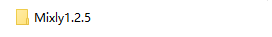

Open the Mixly 1.2.5 folder, select the corresponding EXE file, and double-click to open the software.
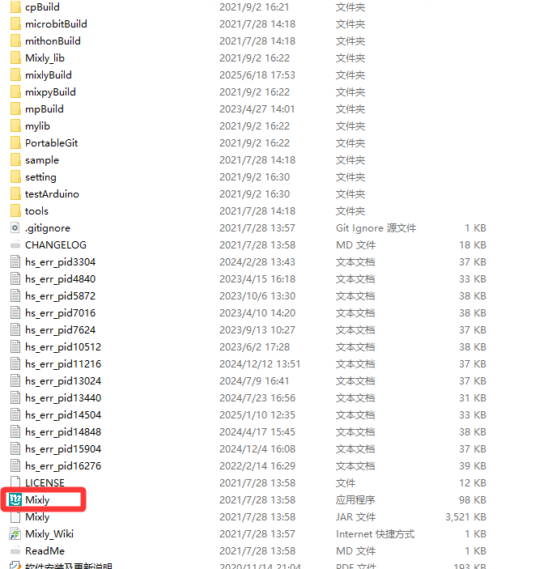
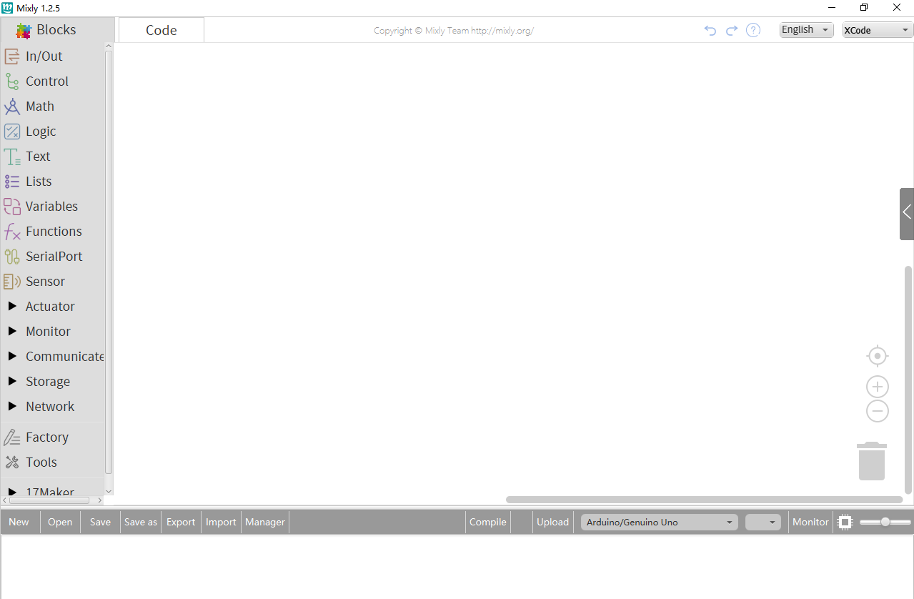
After opening the Mixly software, select the English mode in the upper right corner, as shown in the following figure.
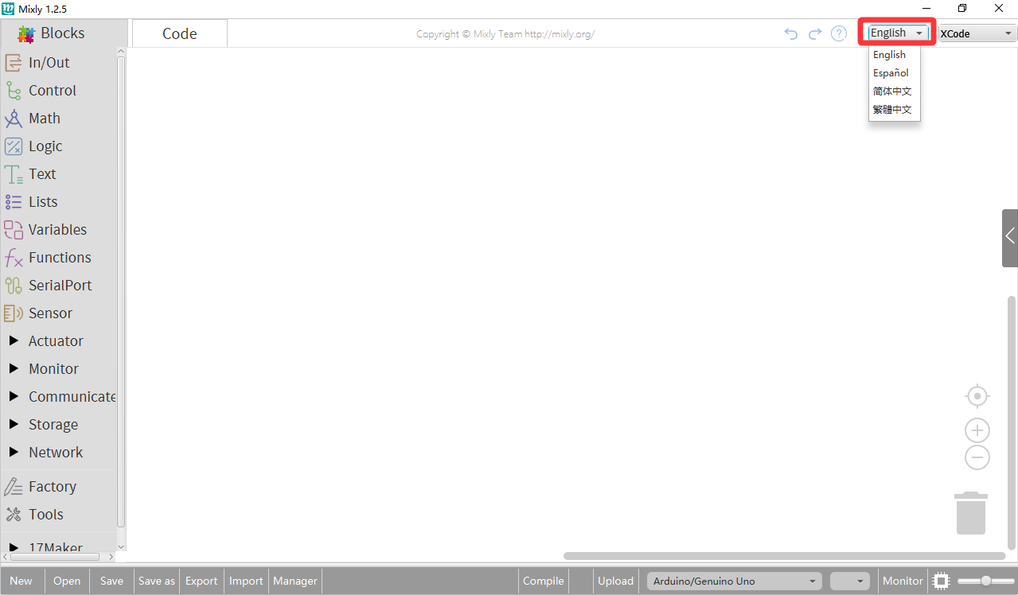

Upon seeing the Arduino folder in Mixly 1.2.5 again, double-click to open the Arduino programming software, as shown in the following image.

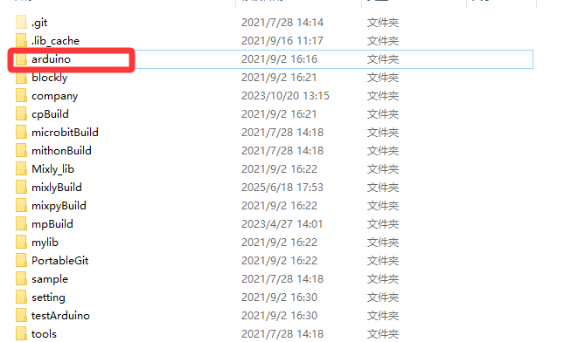
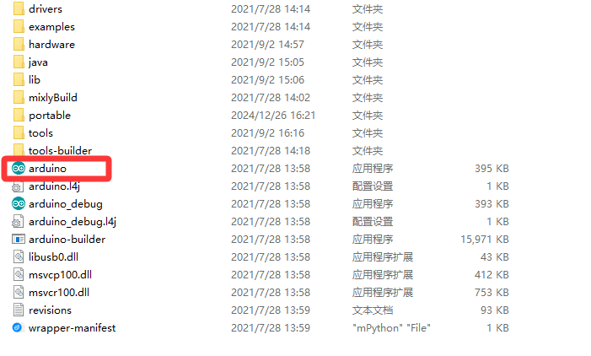
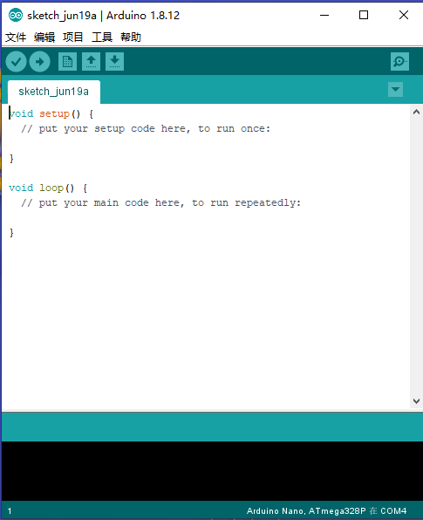
After opening the Arduino software, select the file in the upper left corner, click on preferences, and then choose the English magic mode. After closing and reopening the software, it will change to English mode.
